Type of Presentation: Indicate your preference for Oral or Poster presentation here.
Conference Subtheme: Indicate the conference subtheme category for the presentation here.

Title of the paper or presentation here

(The title should be in 13 font size, Tımes New Roman, Bold, Sentence Case, and Centered)
Name of First Author^{1,}*, Name of Second Author², etc³ (indicate the first names and surnames of all authors with middle names as initials)
¹Affiliated company/institution address of the first author
²Affiliated company/institution address for the second author
*Corresponding author’s email address
(The font size for the author names and affiliation information should be size 11 and in Times New Roman, and Centered. Also, use asterisk to highlight corresponding author)

Abstract
Authors should insert or type in their abstract under this section. Typically, the abstract should be a summary of the research or project to be presented at the conference, indicating its relevance, objective, main method(s), and key findings. To ensure consistency in the presentation of abstracts in the conference programme, the abstract should be typed in 11 font size, Times New Roman, single line spacing, justified and must not be more than 250 words. All papers should be submitted at https://ghiejournal.com/index.php/jghie/about/submissions. The deadline for paper submission is 10th January 2026.

Keywords: Maximum of five (5) words should be listed here separated by commas in font size 11.

Introduction
The paper must have an Introduction section as the first section of the main text after the keywords. The content of this section should commonly include a brief background, short review of the pertinent literature in the study field, and the purpose, significance and possible innovation or contribution to knowledge of the research or project. The heading of this section and all main headings in the manuscript should be in 12 font size, Times New Roman, bold, and Title Case. The page format should be A4 paper size with 2.5 cm wide margins from the right, left, top and bottom. Indents should be used when starting a new paragraph after the first paragraph.

Materials and Methods
This section must provide clear sufficient information on the experimental procedures, investigations, measurements, and analyses employed in the study to permit repetition of the work. Commonly, modifications made to known employed methods must be clearly explained. However, if already known methods are simply employed in the study, then appropriate reference(s) must be made to them instead of re-producing the known details. Also, a description of the study area including a detailed map, where applicable, must always be provided under this section. The theory and practice behind the methods, and the reasons for selecting the methods must also be provided.
The section heading could be named differently, and with subheadings and sub-subheadings, depending on the nature of the study, but the overall content should always refelect the employed methods in the study. Subheadings should be typed in 11 font size Times New Roman, bold and sentence case with sub-subheadings also in the same format but in italics.

Results and Discussion
The results and observations of the research or project and their detailed interpretations should be presented under this section. The results should be presented in tables or figures, whenever possible, while their interpretation, significance, and limitation(s) in comparison to relevant contemporary studies are to be clearly explained in the text. In a situation where authors wish to have separate “Results and Discussion” sections, it must be ensured that the results are not repeated under the discussion section. Also, subheadings and sub-subheadings could be introduced under this section when needed.
Tables and Figures (including pictures, maps, photos, and charts) should be inserted at appropriate positions where needed in the manuscript and numbered sequentially in the order in which they are referred in the text (example: see Figure 1 and Table 1). The figure captions should be placed under the figure whereas the table captions should be placed on the top of each table. Captions for all the tables and figures should be typed in 10-point font size Times New Roman in single line spacing. Footnote markers for tables should be consecutive superscript lowercase letters (or asterisks for statistical data) and explained beneath the table body in 9-point font size Times New Roman in single line spacing. Similarly, displayed equations in the manuscript should be generated using Microsoft Word Equation Editor or any equation editor that works in MS Word, numbered sequentially at the right-hand margin in parenthesis and referenced in the text.

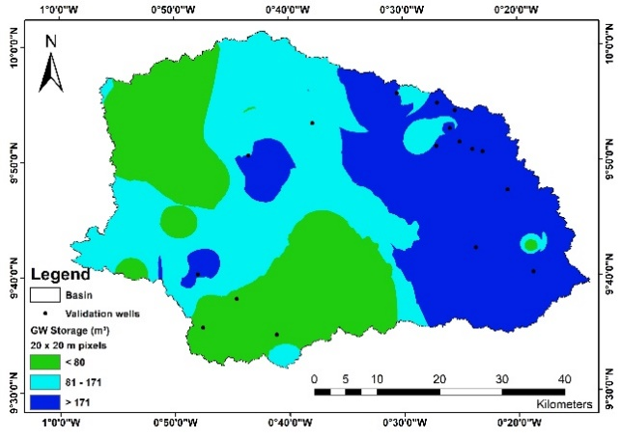

Figure 1 Groundwater storage volume in the Nabogo basin

Table 1 Projected water consumptions (m³/day) in Nabogo basin for the years 2018 and 2048
Category | 2018 | 2048
Domestic | 20,630 | 48,636
Cattle | 4,595 | 6,509
Sheep & Goat | 2,449 | 10,490
Poultry | 990 | 42,219
Total | 28,664 | 107,853

Conclusions
This section should provide a summary of the key findings, innovation(s), implications for policy, and/or any recommendation(s) for further work. It must be emphasized that the papers submitted for the conference should not be more than 7500 words, prepared following the guidelines indicated in this template and submitted at https://ghiejournal.com/index.php/jghie/about/submissions. Automatic page numbering and continuous line numbering should be applied for all the pages of the paper. More information on the guidelines for paper preparation can be obtained in the Author Guidelines for the Journal of the Ghana Institution of Engineering (JGhIE) available at the website of the journal.

Acknowledgement
This section is for acknowledging the funders and organisations or person(s) who supported the research or project. Full names of funding organisations and institutions must be provided.

Conflict of Interest Declarations
Authors need to disclose any commercial or associations that may pose a conflict of interest here.

References
All the references in the paper should be cited using the author(s) and year in parentheses format and listed alphabetically. The formatting style for listing the various sources of references should be as follows for:
- Books
Last name, other names initial (for all authors). (Year). Title. City of publication: Publisher.
For example:
Kesse, G.O. (1985). The mineral and rock resources of Ghana. Rotterdam: AA Balkema Publishers

Book Chapter

Last name, other names initial (for all authors). (Year). Chapter title. In: Editor's name(s) (ed/s), Book Title. Edition. City of publication: Publisher, Page(s).
For example:
Tsikata, F.S., Brew-Hammond, A. and Osafo, Y.B. (2008). Increasing access to clean energy in Ghana: challenges and initiatives. In: Zilmann, D.N., Redgwell, C., Omorogbe, Y.O. and Barrera-Hernandez, R.K. (eds.), Beyond the carbon economy: energy law in transition law. New York: Oxford University Press Inc., pp. 163-177.

Journal Articles
Last name, other names initial (for all authors). (Year). Article title. Journal name, Volume (Issue), Page(s). Full doi links (if available).
For example:
Tufour, E. O. A. (2022). Optimum axle load limit on the trans west African highway – a case study of Ghana’s coastal corridor. Journal of the Ghana Institution of Engineering, 22 (1), pp. 16-22. https://doi.org/10.56049/jghie.v22i1.7.
Appiah-Adjei, E. K., Shu, L. C., Adjei, K. A., Lu, C., and Deng, M. (2012). Interpretation of pumping test with a radial collector well using a reservoir model. ASCE Journal of Hydrologic Engineering, 17(12), pp. 1397-1407.

- Newspaper and Magazine Articles (whether print or online):
Last name, other names initial (for all authors). (Year). Article title. Newspaper or Magazine name, Volume (Issue), Page/s. Available at: URL link [Accessed date] if available.
For example:
Cardigah, V.K. (2022). Agriculture, Ghana’s industrialization. Daily Graphic. Available at: https://www.graphic.com.gh/features/opinion/agriculture-ghana-s-industrialisation.html [Accessed 25 November 2022].

Reports (consultancy, project, thesis, or any technical report):
Author/Organisation’s name. (Year). Title of report. Type of Report. City of publication: Publisher.
For example:
Osei-Nuamah, I. (1998). Hydrogeological evaluation of formations in Ashanti Region, Ghana.
Master Thesis. Kumasi: Kwame Nkrumah University of Science and Technology.

